**C.V**

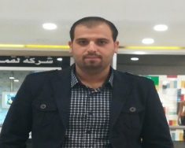

Samir Khalil Farman

**Home Address:** Erbil – farman baran

Phone number: +**964 07507642120**

**E-mail address:** [samir_khalil88@yahoo.com](mailto:samir_khalil88@yahoo.com)

**Nationality**: Iraqi- Kurdish

**Gender:** male

**Data of Birth :** 2/1/ 1988

**Relevant skills:**

I’m proficient in using computers in general fields, especially, using Microsoft office. I am and also accustomed with Microsoft power point, Photoshop and excel. I frequently use the internet.

**Languages spoken:**

Kurdish: (excellent).

Arabic: (excellent).

English: (good).

**Education:**

Institute of computers

Graduated in sixth grade

Institute of the capital of Kurdistan computer 2014

**Work experiences:**

1. **1. I worked at Fast lik In 2014 Department of QualityCommunication Service.**
2. **I worked for newroz Telecom In the Adsl Quality Assurance. 2016**
3. **I worked at Newroz Telecom in the ADSL division . 2017**
4. **I worked on the programs of the Network Analizer with the program Trapl A**

I worked for other companies

I worked for MediaNet Sales Representative

I worked for Sales Supervisor